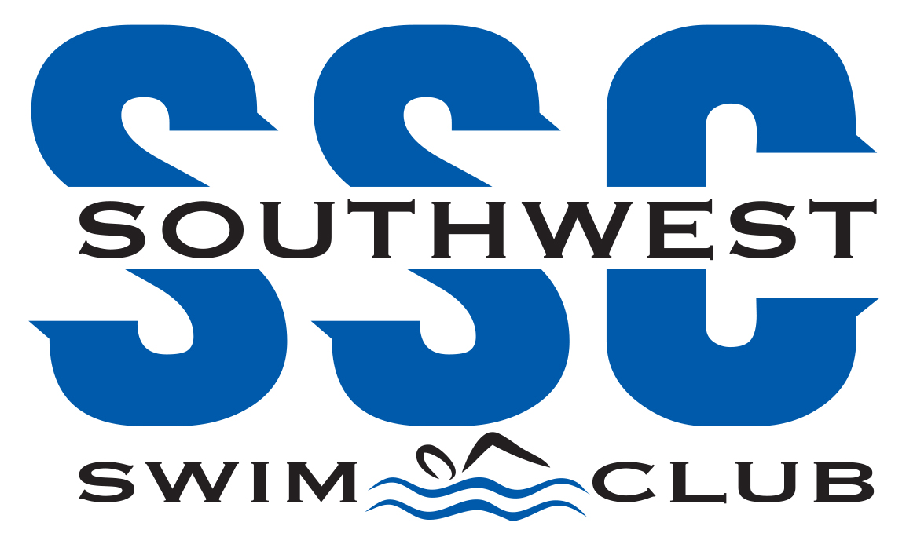

I acknowledge that I have received, read, and understood the Minor Athlete Abuse Prevention Policy and/or that the Policy has been explained to me or my family. I further acknowledge and understand that agreeing to comply with the contents of this Policy is a condition of my membership with Southwest Swim Club (USA Swimming member club).

Name: ______
Signature:
Date: ______

